Year 12 Ancient History – EST Content and Study 2024 NAME:__________________

UNIT 3: Power and Authority - *Rome, the Late Republic to the Lex Manilia c. 133–66 BC*E

The 2024 EST will focus on:

**Marius and/or Marius and the transition to Sulla as leader (up to the First March on Rome only)**

__________________________________________________________________________________

**CONTENT**

Key people, ideas and events of the period

* key people, ideas and/or events and their influence on society
* the role of people, ideas and events as forces for change in the period
* examples of change in the period (political, social, religious, cultural, military and/or economic)

Effects of continuity and change in the period

* short-term and long-term effects of change in the period

**SKILLS**

Analysis and use of sources

* identify the origin, purpose and context of historical sources
* analyse, interpret and synthesise evidence from different types of sources to develop and sustain an historical argument

Explanation and communication

* develop texts that integrate appropriate evidence from a range of sources to explain the past and to support and refute arguments

The following themes should be considered, where appropriate, throughout the elective:

* military
* political
* economic

**Career of Gaius Marius (133–87 BCE) and extraordinary commands up to 66 BCE**

* Marius’ background; First consulship and the reasons for this consulship
* Marius’ reforms to the Roman army; implications and consequences of the emergence of a new professional army
* successive consulships and reasons for these consulships
* relationship between generals and tribunes; role of tribunes in Marius’ career
* concept of extraordinary commands; types of extraordinary commands; examples of extraordinary commands up to 66 BC
* role of tribunate; extent of support for extraordinary commands; importance of army and extraordinary commands to politics and foreign policy

**Career of Sulla (90–78 BCE)**

* Sulla’s background; transfer of Mithridatic command to Marius by the tribunate
* Sulla’s first march on Rome; Sulla in the East and the events in Rome

EST COMMON QUESTIONS:

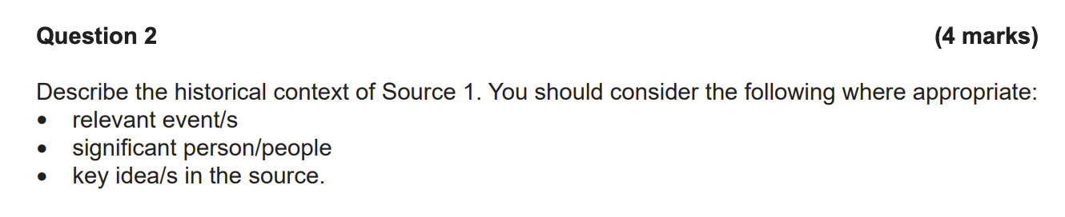

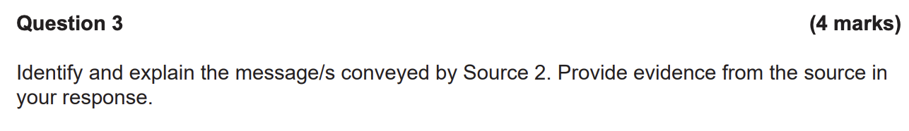

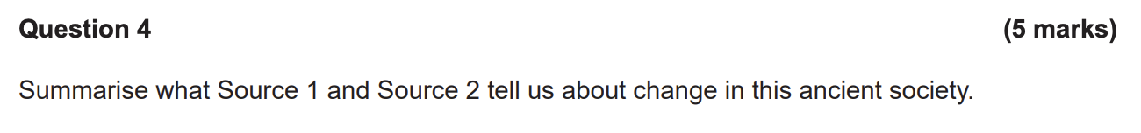

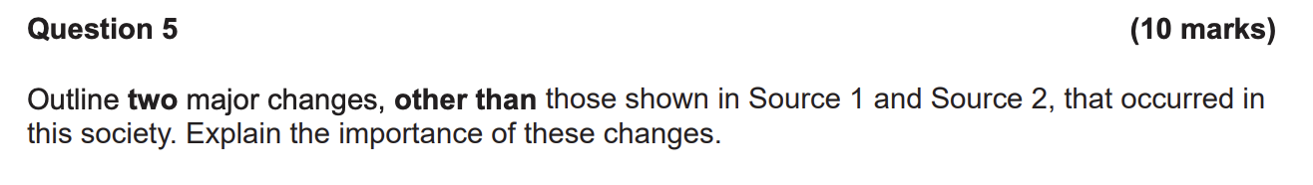

**Career of Gaius Marius (133–87 BCE)**

1. **Background and First Consulship:**
   * Gaius Marius was born around 157 BCE in Cereatae, near Arpinum (Latium, Italy).
   * He served as consul seven times (107, 104–100, 86 BCE).
   * Marius was the first Roman to demonstrate the political support a successful general could gain from his old army veterans
2. **Reforms to the Roman Army:**
   * Marius implemented significant reforms to the Roman army:
     + Abolished property qualifications for military service, allowing landless citizens to enlist.
     + Introduced a professional standing army (legions) with standardized equipment.
     + Soldiers swore loyalty directly to their generals, creating a strong bond.
   * Implications:
     + The emergence of a professional army shifted loyalty from the state to individual generals.
     + Marius gained immense political influence through his loyal troops.
3. **Successive Consulships:**
   * Marius held multiple consulships due to his military successes and popularity with the soldiers.
   * His consulships were essential for maintaining power and influence.
4. **Generals and Tribunes:**
   * Marius had a complex relationship with tribunes (defenders of the plebs).
   * Tribunes played a role in Marius’ career by supporting his reforms and legislation.
5. **Extraordinary Commands:**
   * Marius held several extraordinary commands:
     + **Against Jugurtha (Numidian War):** Made an excellent impression as an officer-cadet.
     + **Against the Cimbri and Teutones:** Successfully defended Rome against invading Germanic tribes.
     + **Against Mithradates VI of Pontus:** Fought in Asia Minor to protect Roman interests.
6. **Role of Tribunate and Political Importance:**
   * Marius’ tribunate allowed him to propose legislation and challenge the aristocracy.
   * Extraordinary commands and the loyalty of his troops were crucial for his political influence and foreign policy decisions.

**Career of Sulla (90–78 BCE)**

1. **Background and Transfer of Mithridatic Command:**
   * Lucius Cornelius Sulla (Sulla) was born in 138 BCE.
   * He served as a quaestor (financial magistrate) under Gaius Marius during the Jugurthine War.
   * Sulla’s capture of Jugurtha marked the start of his feud with Marius.
   * Marius’ jealousy led Sulla to transfer his loyalty to Marius’ co-commander, Quintus Lutatius Catulus.
2. **Social War and Consulship:**
   * Sulla fought in the Social War (90–89 BCE) alongside Rome’s Italian allies.
   * In 88 BCE, he became one of the two consuls and was placed in command of the war against King Mithradates VI of Pontus.
3. **War Against Mithradates:**
   * Sulla marched to Greece to fight Mithradates.
   * By 87 BCE, most of Greece was under his control, and he captured Athens.
   * His marriage to Caecilia Metella solidified important alliances.
4. **Dictatorship and Constitutional Reforms:**
   * Sulla returned to Rome and became dictator (82–79 BCE).
   * He carried out constitutional reforms to strengthen the Roman Republic.
   * His actions had a lasting impact on Roman politics and governance.